PROCEEDINGS PREPARATION GUIDELINES
Western Nutrient Management Conference
MARCH 5-6, 2025

DUE DATE: January 15th, 2025

- Proceedings articles must be between three and six pages in length, including tables, figures, and references

- 12 point Times font; single spaced

- One inch margins top, bottom, right and left; full justification; first line indent 0.3”

- Manuscript to include Title (short), Author(s)/Location, Abstract Objectives (brief), Methods (brief), Results and Discussion.

- Title: 14 pt Times font, bold, centered, all caps, followed by single space

- Main Section headings: 12 pt Times font, bold, all caps, left-justified; subheadings: 12 pt Times font, bold, initial caps, left-justified

- English Units preferred. If using metric units give English unit equivalents

- ASA publication format for tables and figures. All figures and tables to be embedded within the text.
  - Use of color is allowed and encouraged since these will be published online and not in hard copy
  - Suggest graph be 2 inches by 3 inches and minimum 10 pt font used.

Submit to the WNMC website as a word document by January 15th, 2025 at: https://westernnutrientmanagement.org/Abstracts/Abstract_Management.

Address questions regarding content to:
Amber Moore, Extension Soil Fertility Specialist
Oregon State University
Department Of Crop and Soil Science
3017 ALS
Corvallis, OR 97331-7306
541-737-2870
amber.moore@oregonstate.edu

Address questions regarding submission to:
Mershon Tobin, info@westernnutrientmanagement.org
217-762-7955

Example follows
Biofuel Byproducts as Nitrogen Sources for crops

A. Moore¹, A. Alva², H. Collins², and R. Boydston²
¹University of Idaho, Twin Falls Research and Extension Center
² USDA ARS, Prosser, Washington

Abstract
The new development of ethanol and biodiesel plants in the United States is creating a large, and potentially excessive, quantity of byproducts in the forms of distillers grains and oilseed meals. The organic nitrogen (N) compounds in these byproducts rapidly mineralize in soils, showing the potential to be used as a N fertilizer source to plants. The objective of this research is to evaluate the application of biofuel byproducts on yield, size distribution, and nutrient uptake for Russet Umatilla potatoes. Canola meal, mustard seed meal, dried distillers grains, and a urea fertilizer (46 %N) were hand-applied at rates of 100, 150, and 200 lb total N/acre. The lowest tuber yield for mustard meal was at the highest N rate, and may be related to the isothiocyanate concentration in the meal. Potatoes fertilized with canola meal, mustard meal, and dried distillers grains had higher tuber yields and proportionally heavier tubers at all rates, compared to potatoes fertilized with urea. It appears that the urea fertilized potatoes were suffering from a sulfur (S) deficiency, which could cause a tuber yield reduction.

Introduction
With concerns in the United States regarding the availability of petroleum-based fuels, interest in plant-based fuel feedstocks is on the rise. For example, as of 2008, there are seven ethanol plants proposed for Washington and four for Idaho. There are also two active biodiesel operations in Washington and one in Idaho. The biofuel industry introduces the production of new byproducts to our region, specifically dried distillers grains from ethanol production, and canola and mustard meals from biodiesel production. Approximately 56 lbs. of dried distillers grains are generated in the production of one gallon of ethanol, and 11 and 18 lbs of meal is produced to make one gallon of canola and mustard-biodiesel, respectively.
One option for recycling biofuel byproducts is to apply the material to croplands as a fertilizer source. During the fermentation process in corn ethanol production, proteins are degraded and starches are converted to ethanol and carbon dioxide, leaving rapidly available organic N compounds that can be released to plants as a primary N source. The crushing and pressing process of canola and mustard seed for oil production leaves highly degradable N compounds in the pressed meals. In a previous study conducted by Moore and Alva, the proportion of N available from the dried distillers grain and mustard meals was 56 and 61%, respectively, over a 210 day incubation period. In addition, both grains and meals contain significant concentrations of phosphorus (P), potassium (K), and S, which are all essential nutrients for plants. Distillers grains and oilseed meals show the potential to be particularly useful fertilizers for potatoes, which have N requirements ranging from 200 to 350 lb/acre, depending on the variety and the growing conditions. These materials also show promise in the organic markets, where economic and effective N sources are often difficult to find. In addition, isothiocyanate compounds in mustard meals have shown the potential suppress weed, fungal, nematode, and insect populations, which would be immensely beneficial for organic growers.
The objective of this research is to evaluate biofuel byproducts as a nutrient source for Russet Umatilla potatoes by evaluating tuber yield, tuber size distribution, soil pH, and concentrations of nitrate (NO₃), P, K, and S in the plant tissue.

Methods
The field research for this experiment was conducted on the USDA ARS Research Farm near Paterson, in south central Washington. This region of Washington receives an average of 7-10 inches of precipitation per year, and is regarded as a high yielding region for process potatoes. Russet Umatilla potatoes were planted in a Quincy sand (Mixed, mesic Xeric Torripsamments), and irrigated through pivot irrigation. The pre-plant N source treatments were canola meal, mustard meal pressed from v. Ida Gold mustard seed, dried distillers grains, urea (46% N), and an untreated control. Nitrogen content of the amendments is listed in Table 1. Amendments were hand-applied at rates of 100, 150, and 200 lb total N/acre for all amendments, and incorporated with a roto-tiller prior to planting. The total amount of each material applied is listed in Table 2, based on dry weight. Nitrogen was also applied in-season at a rate of 120 lb N/acre for all plots through multiple application with pivot fertigation as urea ammonium nitrate (UAN), to maximize tuber bulking rates. Tuber yield and size distribution was determined post-harvest for all plots. Soils were sampled monthly for nitrate nitrogen (NO₃-N) and ammoniacal nitrogen (NH₄-N) at 0-12 and 12-24 inch depths (data not shown). Petioles were sampled weekly at the 5th node, and analyzed for NO3, P, K, and S concentration in the tissue.

Table 1. Nitrogen content of amendments used in this study.

Amendment | % total N
Canola meal | 5.3
Mustard meal | 4.7
Dried distillers grain | 4.3
Urea | 46.0

Table 2. Quantities of amendment applied to meet nitrogen rates.

Treatment | N rate (lb/acre) | Material applied (ton/acre)
Mustard meal | 100 | 1.1
Mustard meal | 150 | 1.6
Mustard meal | 200 | 2.1
Canola meal | 100 | 0.9
Canola meal | 150 | 1.4
Canola meal | 200 | 1.9
Dried distillers grains | 100 | 1.2
Dried distillers grains | 150 | 1.7
Dried distillers grains | 200 | 2.3
Urea | 100 | 0.11
Urea | 150 | 0.16
Urea | 200 | 0.22

Results and discussion
Overall tuber yields ranging from 800 to 860 cwt./acre did not vary greatly between canola meal, mustard meal, and distillers grains amended soils (Figure 1). We were not expecting a drastic difference in yield among the biofuel byproduct amended soils, as the byproducts have similar N contents and N mineralization rates. Focusing on specific amendments, the lowest tuber yield for mustard meal was at the highest N rate in the experiment at 200 lb total N/acre (figure 1). We speculate that the decrease in yield is related to the isothiocyanate concentration in the meal. Tuber yields were lower for soils amended with urea, using the same total N rate that was used for the biofuel byproduct amendments. This result was not expected, because N in urea is assumed to be 100% available to plants, and oilseed meals and distillers grains have only up to 60% available N. The decrease in yield for urea-amended soils could be related to lack of additional nutrients, specifically S, in the soil. Urea amended soils had a larger proportion of tubers under 4 oz. than the soils amended with biofuel byproducts. Again, this could be related to low S, which is a key component in tuber growth.
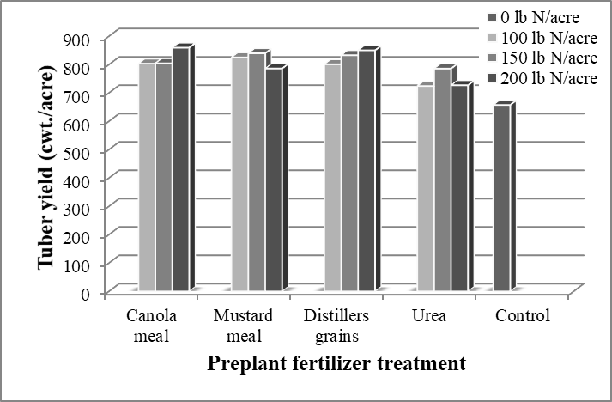

Figure 1. Tuber yields for Russet Umatilla potatoes grown on a Quincy sand in Paterson, Washington, as affected biofuel byproducts as preplant nitrogen sources.

Petiole NO₃-N concentrations for Urea treatment in central Washington were consistently at or above recommended concentrations from WSU extension. For biofuel byproducts, petiole NO₃-N concentrations were within recommendations for the initial vegetative stages of growth, but at the lower end of the range for the tuberization and tuber bulking stages. Petiole N in distillers grains were similar to control. Based on these results alone, one would expect to see higher tuber yields with the urea treatment.

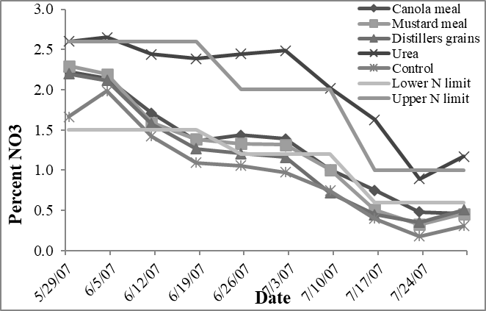

Figure 2. Fifth node petiole NO3-N concentrations from Russet Umatilla potatoes grown on a Quincy sand in Paterson, Washington, as affected biofuel byproducts as preplant nitrogen sources.

Recommended Petiole S range for central Washington is between 0.15 and 0.20 % S for the duration of the growing season (two black lines). Soils at lower end of recommended S content, at 2 ppm SO₄-S seem to have created S limiting conditions for tuber growth. Mustard meal treated plants were generally within the recommended range of S concentrations, and had the highest petiole S concentrations of all of the amendments used in this study. The isothiocyanate compounds in the mustard meals contain S. Growers may not need to apply S when using mustard meals, depending on application rates and crop needs. Petiole S was generally greater for distillers grains and canola meal than urea. Although not as great as mustard meal, S compounds in canola mea and distillers grains appear to be available for uptake by potato plants, thus contributing to tuber growth.

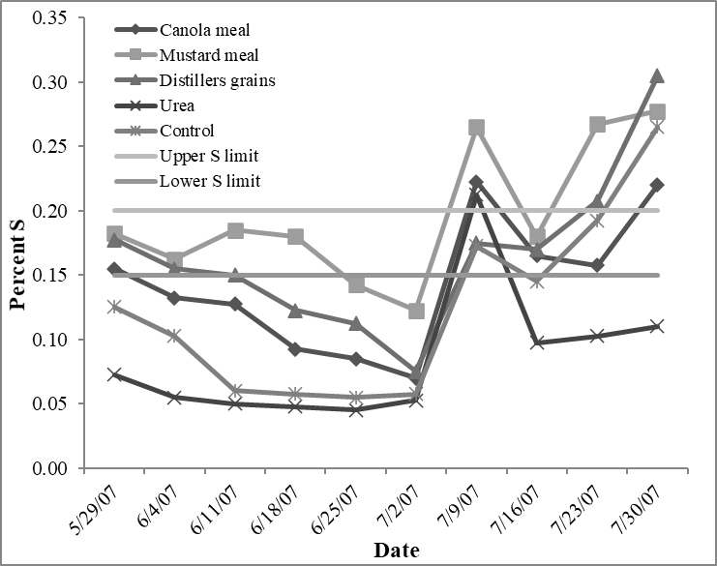
Figure 3. Fifth node petiole S concentrations from Russet Umatilla potatoes grown on a Quincy sand in Paterson, Washington, as affected biofuel byproducts as preplant nitrogen sources
Petiole P and K concentrations were similar for all treatments, including the non-amended control, illustrating that the soils were not P or K limiting.
In summary, Russet Umatilla potatoes fertilized with canola meal, mustard meal, and dried distillers grains had higher yields and larger tubers compared to urea, at least under S-limiting soil conditions. Applying mustard meal at a N rate of 200 lb N/acre or higher shows the potential to reduce tuber yields, due to toxic concentrations of isothiocyanates. Higher tuber yields and lower nitrogen uptake with biofuel byproducts in comparison to urea may be attributed to the concentration of S and other nutrients in the soil, as well as biological, physical, and/or chemical unknowns.

